1.R = R1 + R2 + R3
R= 20 + 30 + 50
R = 100

2.I=125\100
1.25

3. I1 = I2 = I3 = 1.25A

4.Ohm's law (V = I *R) for each individual resistor.
- 20 Ohm Resistor:
V1 = 1.25* 20 = 25V
- 30 Ohm Resistor:
V2 = 1.25A * 30 = 37.5V
- 50 Ohm Resistor:
V3 = 1.25 A * 50 = 62.5V

5. Use Watt's law P = V * I
- 20:
P1 = 25 V*1.25A = 31.25W
- $30:
P2 = 37.5V* 1.25A} = 46.87 W
- 50:
P3 = 62.5V *1.25 A} = 78.125W

PART B
- 1/R = 1/R1 + 1/R2 + 1/R3
1/R = 1/20 + 1/100 + 1/50
1/R = 8/100
R = 100/8
R = 12.5
- I=125/12.5
10
- Ohm's law (I = V / R)
for each individual resistor.
20 Ohm Resistor:
I1 = 125 / 20 = 6.25A
100 Ohm Resistor:
I2 = 125 / 100 = 1.25A
50 Ohm Resistor:
I3 = 125 / 50 = 2.5A
- V1 = V2 = V3 = 125V
- Use Watt's law P = V * I
20 Ohm Resistor:
P1 = 125V * 6.25A =
781.25W
100 Ohm Resistor:
P2 = 125V * 1.25A =
156.25W
50 Ohm Resistor:
P3 = 125V * 2.5A =
312.5W

PART 2:



Item | Quantity | Component Description | Schematic Designator
1 | 1 | ESP32 Development Board | U1
2 | 1 | DHT22 Temperature & Humidity Sensor | U2
3 | 1 | 10k Ω Resistor (Data Pull-up) | R1

DIAGRAM 1
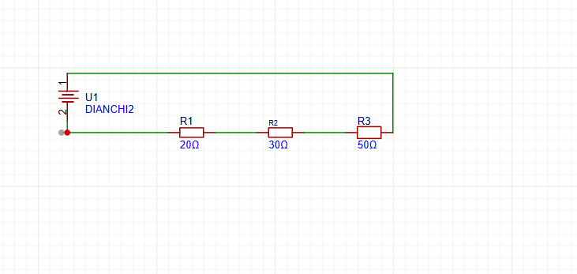

DIAGRAM 2

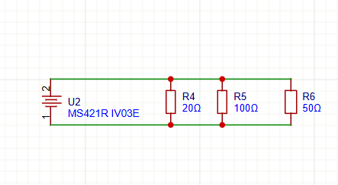

DIAGRAM 3
